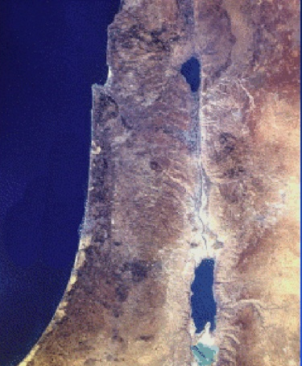
Phoenicia
Judea
Idumea
Decapolis
Samaria
Galilee
Sea of Galilee
Dead Sea
Mediterranean
Sea
Tyre
Sidon
Caesarea Philippi
Bethsaida
Gadara
Capernaum
Nazareth
Jerusalem
Jordan River
Dalmanutha?
Jericho
Bethany
Gennesaret
Bethphage
Bodies of Water
Regions
Cities or Towns
Sea of Galilee
Galilee
Decapolis
Samaria

